

TurtleBot Power Interface Shield
Includes  - 1x Mini-Din 7 to MTA100 Cable  - 1x Turtlebot Power Interface Shield  - Stacking Headers sold separately | 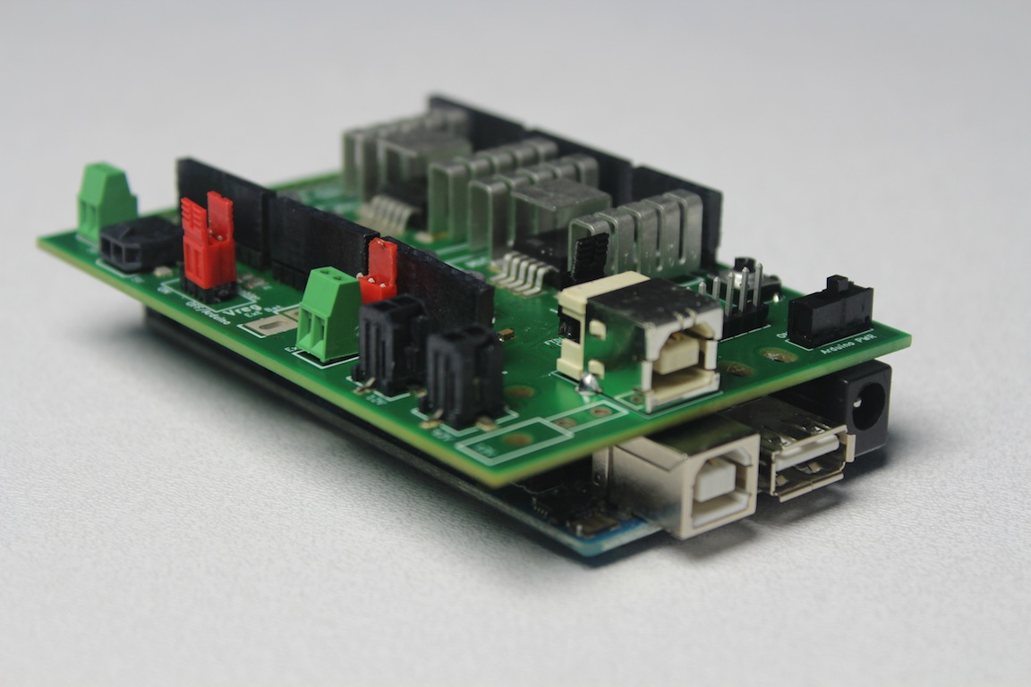

http://www.IHeartEngineering.com
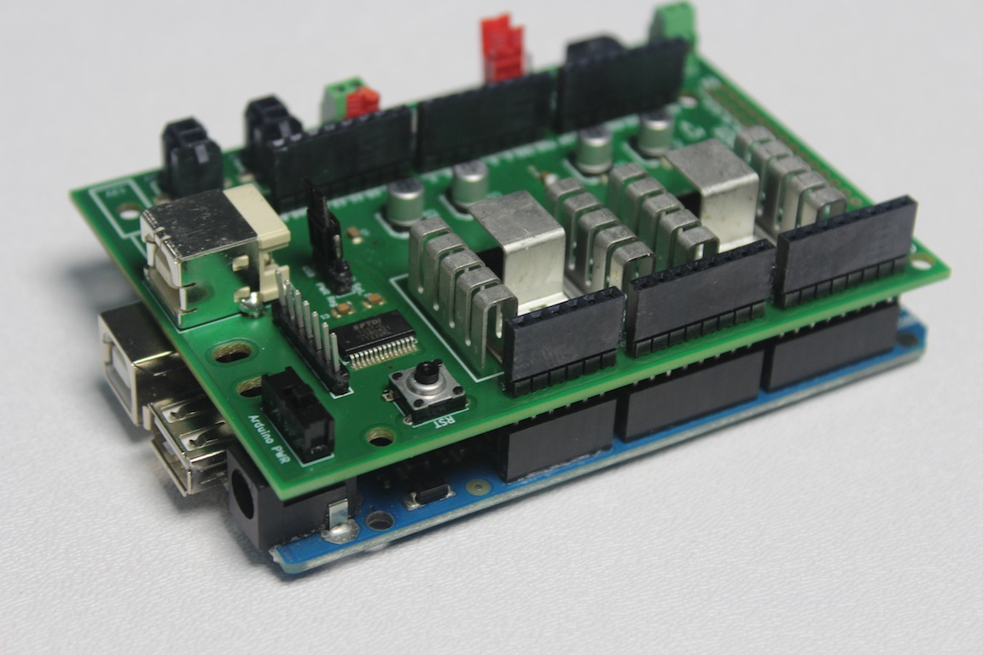
Description
The Power Interface Shield is a board made for PC to Roomba (or iCreate) communication using an integrated FTDI chip and power regulator for Turtlebot devices.
The Arduino board RX and TX pins are tied to the Roomba’s TX and RX respectively when the shield is stacked to an Arduino Uno or Mega board.
The board has two voltage regulators, 5V and 12V, that can be controlled by an Arduino board. If no Arduino board is present, the voltage regulators can be enabled and disabled with shunts.

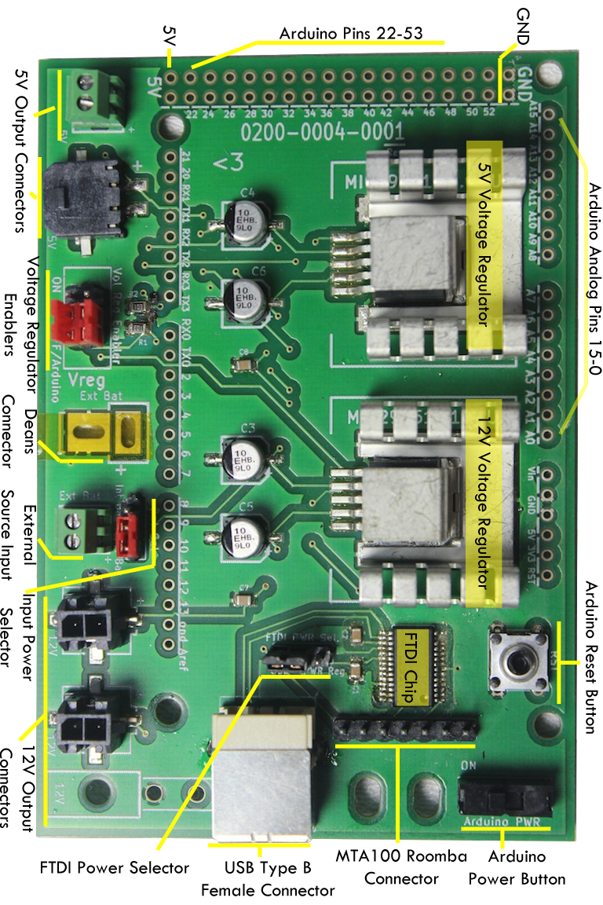
Power Supply Input
Select between using the Roomba’s internal battery or an external battery to supply power to the 5V and 12V voltage regulators. There are two different external battery connector: a Deans connector and a 2-pin Screw Terminal block.
WARNING: Not using the proper power supply to turn on the Arduino board may cause damage to the Arduino Board. Use a power supply within the recommended input voltage range (recommended input voltage for the Arduino Uno is between 7V and 12V).

Voltage Regulator Enabler
Enable the 5V and 12V voltage regulators independently with a shunt. There are two positions on the jumpers: always on, and off or Arduino-controlled if an Arduino board is present. The Arduino board digital pin 6 enables the 5V regulator and pin 7 enables the 12V regulator. Pins 6 and 7 are tied to ground through a 1k-Ohm pull down resistor.

Power Supply Output
The TurtleBot Power Interface Shield Rev. 01 has three 12V output connectors and two 5V output connectors. Rev. 02 has only two of each voltage output.

FTDI Power Select
Using a shunt select how to power the FTDI chip; using the USB 5V power supply or the output 5V from the shield's 5V regulator. Both supplies have a common ground.

Arduino Power Switch
A slide switch turns on or off the Arduino board. The input power (Internal or External battery depending on the selector) is connected to the Arduino board's Vin pin.
WARNING: Not using the proper power supply to turn on the Arduino board may cause damage to the Arduino Board. Use a power supply within the recommended input voltage range (recommended input voltage for the Arduino Uno is between 7V and 12V).

LED Indicators *for Rev. 02 and above
Two LEDs attached to the FTDI chip indicate data transmission. They are properly labeled RX and TX. There is a LED that turns on when the Arduino Power Switch is turned on. Two LEDs light up individually when the 5V and 12V regulators are enabled.

Shield Stacking
The TurtleBot Power Interface Shield can be stacked on the Arduino Uno, Arduino Mega, Arduino Duemilanove, and other Arduino boards with similar specifications.

Soldering
Solder stacking headers to stack the shield to an Arduino board. Place the stacking headers from top to bottom and turn the shield upside down as seen on the picture. Solder one pin at a time applying enough heat and solder. Repeat process for Deans connector (not supplied).
If using regular header pins (non-stacking), place the pins on the Arduino Board, stack the shield on top and solder from the top side. That way the pins remain aligned with the Arduino Board.
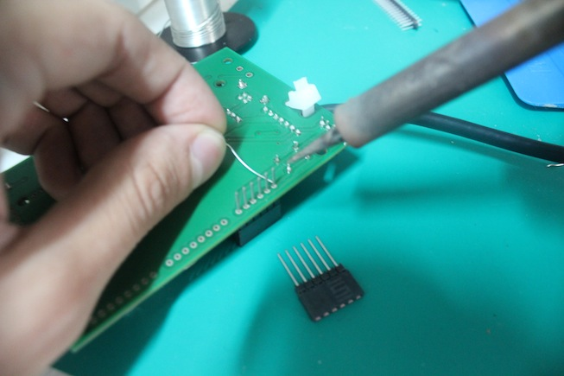

USB Cable
The TurltleBot Power Interface Shield Rev. 01 board uses a Type B USB connector.
The TurltleBot Power Interface Shield Rev. 02 board uses a Micro B USB connector.
Use a zip tie to securely attach the cable to the board.

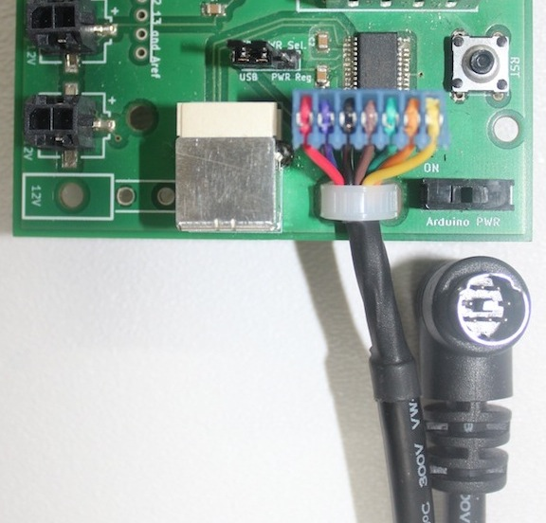

Mini-Din 7 Cable Pinout
A Mini-Din 7 to MTA 100 cable (provided) connects the Roomba with the board.

Mini-Din 7 to MTA100  Cable pinout | 1. Red wire  2. Purple wire  3. Black wire  4. Brown wire  5. Orange wire  6. Yellow wire  7. Green wire  8. Drain wire
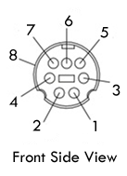

Roomba Mini-Din 7 pinout

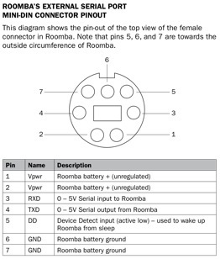

NOTE: pin 5, used for the baud rate selector on the iCreate, is broken out in the TurltleBot Power Interface Shield Rev. 02 board.

Resetting Roomba
To reset the Roomba and bring it to default values, press and hold the SPOT and DOCK buttons for 12 seconds. When reset, the Roomba plays a melody about a second after releasing the buttons. The Roomba 500 Series default baud rate is 115200 bps.

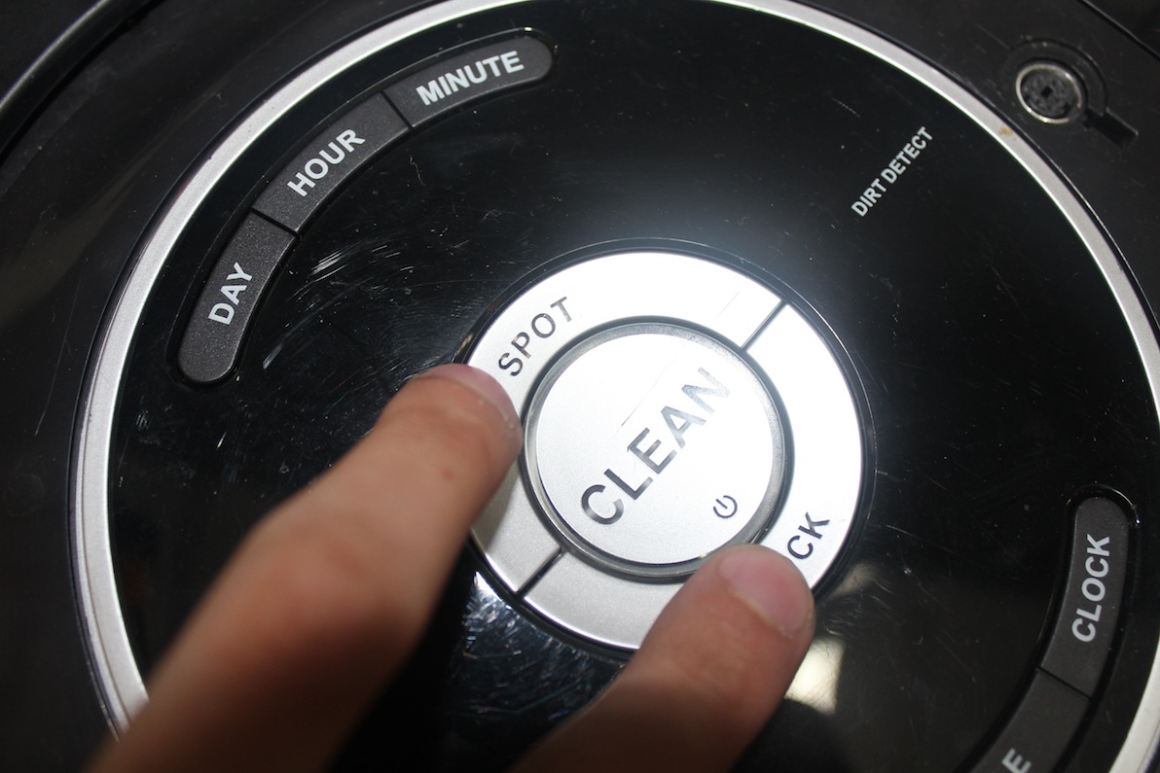
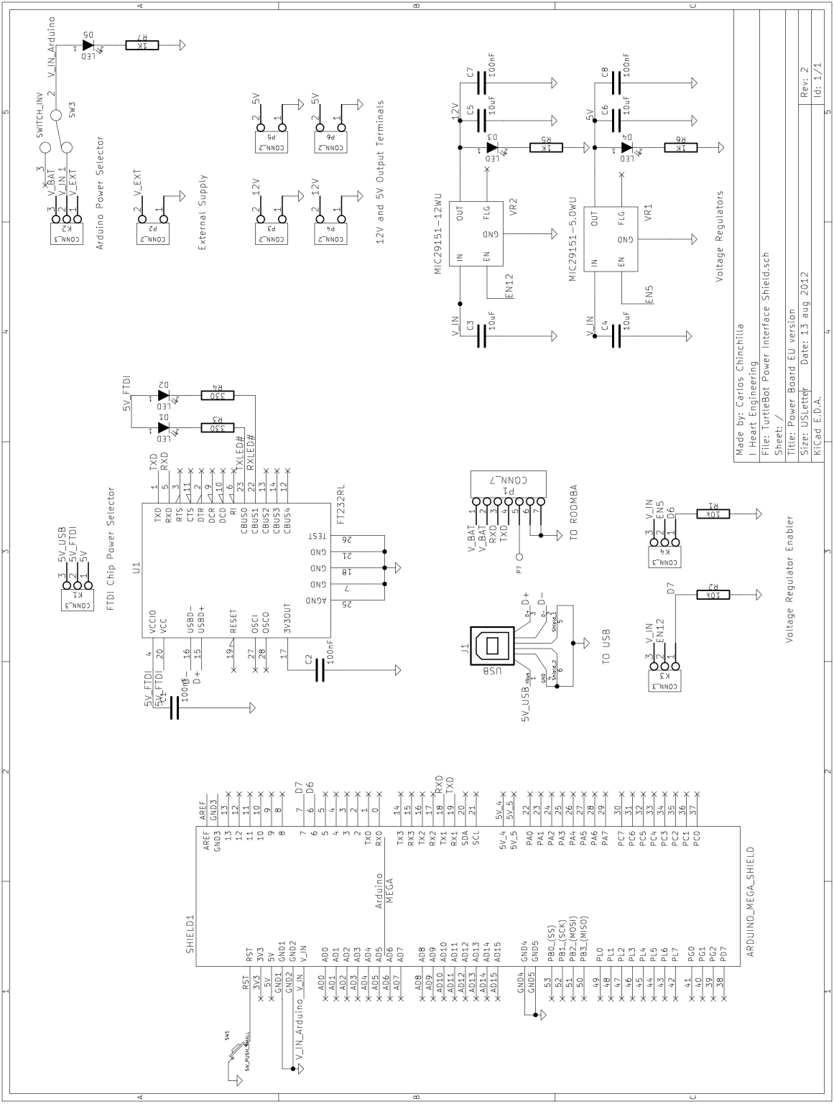
Serial Communication Test
To test for PC-Roomba communication, use the C-Kermit terminal or any preferred terminal. Turn off the Roomba, connect it to the shield and the shield to the computer, and type the following in kermit.
SET LINE /dev/ttyUSB0 # or respective location
SET PARITY NONE
SET FLOW NONE
SET CARRIER-WATCHDOG OFF
SET SPEED 115200
CONNECT
Turn on the Roomba. If there is a proper connection, the terminal will print information about the Roomba on screen. If there is no readable text or no text is printed on screen, try changing the baud rate, checking the cable connections, and battery status of the Roomba. If the problem persists, reset the Roomba and use the default baud rate (115200 bsp) or contact tech support.

Tech Support
For any problems, questions, or comments feel free to contact an I Heart Engineering representative via email at support@iheartengineering.com or phone.

License
The FreeBSD Documentation License
http://www.freebsd.org/copyright/freebsd-doc-license.html
Copyright 2012 I Heart Engineering. All rights reserved.

Redistribution and use in source (SGML DocBook) and 'compiled' forms (SGML, HTML, PDF, PostScript, RTF and so forth) with or without modification, are permitted provided that the following conditions are met:
Redistributions of source code (SGML DocBook) must retain the above copyright notice, this list of conditions and the following disclaimer as the first lines of this file unmodified.
Redistributions in compiled form (transformed to other DTDs, converted to PDF, PostScript, RTF and other formats) must reproduce the above copyright notice, this list of conditions and the following disclaimer in the documentation and/or other materials provided with the distribution.

THIS DOCUMENTATION IS PROVIDED BY I HEART ENGINEERING "AS IS" AND ANY EXPRESS OR IMPLIED WARRANTIES, INCLUDING, BUT NOT LIMITED TO, THE IMPLIED WARRANTIES OF MERCHANTABILITY AND FITNESS FOR A PARTICULAR PURPOSE ARE DISCLAIMED. IN NO EVENT SHALL I HEART ENGINEERING BE LIABLE FOR ANY DIRECT, INDIRECT, INCIDENTAL, SPECIAL, EXEMPLARY, OR CONSEQUENTIAL DAMAGES (INCLUDING, BUT NOT LIMITED TO, PROCUREMENT OF SUBSTITUTE GOODS OR SERVICES; LOSS OF USE, DATA, OR PROFITS; OR BUSINESS INTERRUPTION) HOWEVER CAUSED AND ON ANY THEORY OF LIABILITY, WHETHER IN CONTRACT, STRICT LIABILITY, OR TORT (INCLUDING NEGLIGENCE OR OTHERWISE) ARISING IN ANY WAY OUT OF THE USE OF THIS DOCUMENTATION, EVEN IF ADVISED OF THE POSSIBILITY OF SUCH DAMAGE.

